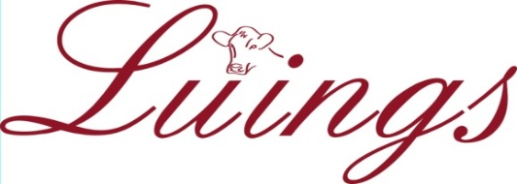

THE LUING CATTLE SOCIETY LTD
Pedigree House | 6 Kings Place | Perth | PH2 8AD
Tel: 01738 448349
Email: secretary@luingcattlesociety.co.uk
VAT NO.: 270 4058 78
The Luing Cattle Society is a charity registered in Scotland, No: SC006667

LUING JOURNAL 2027
COMMERCIAL ADVERTISING BOOKING FORM

Advertising space is available at the following rates for the 2027 publication

Full page black/white | £200 | Full page colour | £295
Half page black/white | £120 | Half page colour | £160
Quarter page black/white | £60 | Quarter page Colour | £95
Outside back cover (colour) | £350 | Inside back/front cover (colour) | £300
Centre Spread Colour (DPS) £395

Cover pages, Centre Spread and specific page bookings taken on a first come first served basis
Please circle (if posting) or highlight and underline (if emailing) which rate you wish to book
All above charges are subject to V.A.T. and invoices will be issued

To enable timely placement and proofreading it is essential that copy deadlines are met. The publication is oriented A4 Portrait
Please repeat last year’s advertisement: |  | (tick or type ‘Yes’ if email)
I will send copy for new advertisement before 19th October 2026 |  | (tick or type ‘Yes’ if email)
Name:
Business Name:
Address:
(incl Post Code)
Email: |  |  | Signed:

PLEASE RETURN BOOKING FORM AS SOON AS POSSIBLE

ARTWORK COPY DUE NO LATER THAN 19th October 2026
Please email copy to: secretary@luingcattlesociety.co.uk

